Null Permutation Analysis: Estimating False-Positive Rate and Type I Error Calibration Across GWAS Correction Methods
Rationale: As highlighted by Yuan and Bill, detection power alone can't distinguish a genuinely sensitive correction method from a permissive one: the same allele frequency, effect size, and homoplasy combinations most likely to produce a true signal could equally produce a flood of false positives under a poorly calibrated method. To address this, we complemented our power simulations with a null permutation-based framework, empirically estimating each method's false-positive rate across the same allele frequency (Set 1) and homoplasy index (Set 2) strata used in the power analysis.
Methods
To estimate each correction method's empirical false-positive rate, we generated null phenotype distributions by permuting the observed EOD/LOD status (n = 623 EOD, n = 917 LOD) across samples using a Fisher-Yates shuffle, which preserves the overall EOD:LOD ratio (0.69:1) while eliminating any true genotype-phenotype association. For each variant in both simulation sets, we generated 20 independent permutations (seeded for reproducibility).
All permuted phenotype-genotype pairs were processed with pyseer, using the same correction methods used in the power simulations. The empirical false-positive rate was calculated as the proportion of null simulations per variant and method yielding a likelihood-ratio-test p-value below the Bonferroni threshold (2.55 × 10⁻⁶). We additionally estimated the upper bound of the true Type I error rate for each bin using a rule-of-three approximation (3/n, where n is the number of contributing null simulations), valid at 95% confidence when zero events are observed across n independent trials (Jovanovic & Levy, 1997).
To assess calibration across the full null p-value distribution, rather than at the Bonferroni threshold alone, we additionally compared observed versus expected null p-values using QQ-plots and computed the genomic inflation factor (λ) for each correction method, defined as the ratio of the median observed to median expected chi-squared test statistic under the null (λ ≈ 1 indicates good calibration; λ > 1 indicates anti-conservative, inflated behavior; λ < 1 indicates conservative behavior).
Results
As a sanity check on the permutation procedure, we examined the crude odds ratio (from the uncorrected effect size estimate) across null replicates by allele frequency bin (Figure S9A). Unlike the systematic bias expected under the artificially enriched ratios used in the power simulations (Figure 2/S2), the crude OR was centered on ≈1 across all allele frequency bins (0.05–0.95, n = 10 SNPs each), confirming the permutation removed genotype-phenotype association without introducing bias.
The false-positive rate observed across pyseer results was 0%, at every allele frequency bin (Figure S9B) and homoplasy index bin (Figure S9C) across all 13 correction methods. However, observing zero significant results across a finite number of null simulations does not guarantee a true Type I error rate of exactly zero. Given the number of null simulations contributing to each bin (200 permutations per AF bin for Set 1, and 240–420 permutations per HI bin for Set 2), a rule-of-three approximation places the upper bound of the true Type I error rate at approximately 1.5% for Set 1 and 0.7–1.25% for Set 2, with 95% confidence.
Beyond this threshold-based check, we assessed calibration across the full null p-value distribution using QQ-plots and the genomic inflation factor (λ; Figure S10). Eleven of the 13 correction methods showed λ close to 1 (range: 0.88–1.06), consistent with good calibration across the null distribution. Two methods, CC (λ = 2.24) and SC (λ = 4.06), showed clear upward deviation from the expected uniform distribution in the upper tail, indicating a trend toward statistical inflation not captured by the threshold-based false-positive rate analysis alone, although neither method's null p-values reached the Bonferroni threshold in this analysis.
Discussion
The upper-bound Type I error rate estimated from our permutation analysis was low (0.7–1.5% at 95% confidence), providing no evidence of inflated false-positive rates across methods. This indicates that the elevated power observed for some correction methods at high homoplasy (e.g., FastTree DP FEM, No correction; Figure 4, Table 2) reflects genuine sensitivity to clonally distributed signal rather than inflated Type I error. Together, these results support that all methods were well calibrated under the null, and that the power differences reported in Figures 3–5 reflect true differences in detection sensitivity rather than differential false-positive rates. The exception is CC and SC, which showed clear tail inflation in the full null p-value distribution (λ = 2.24 and 4.06, respectively; Figure S10), consistent with the inflation observed for these methods in the empirical QQ-plots (Figure 2) and further supporting their exclusion from the correction methods recommended for this dataset.

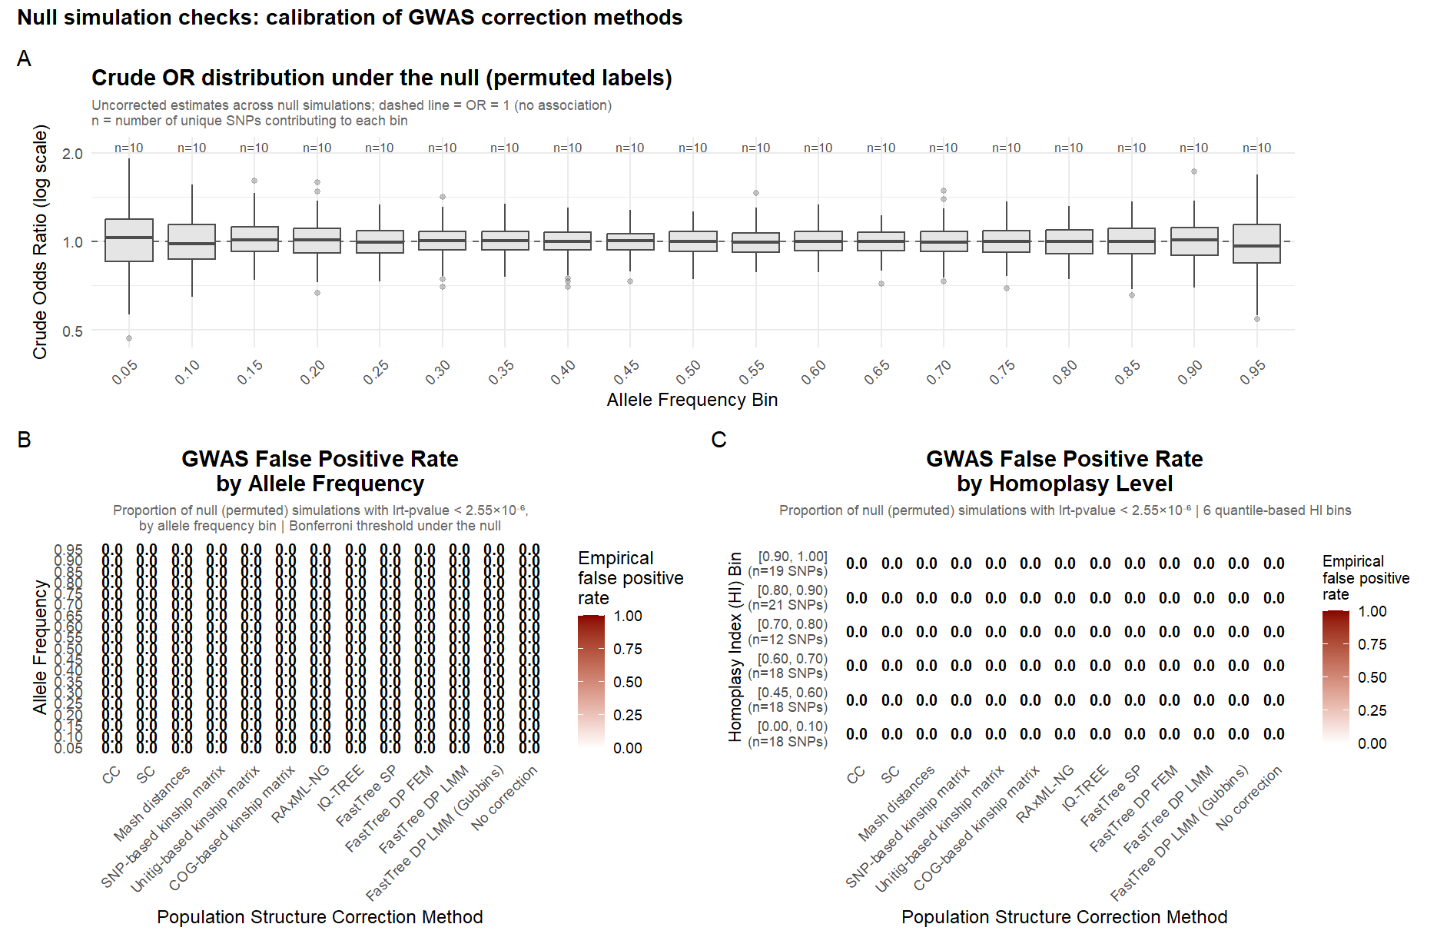
Figure S9. Null simulation checks: calibration of GWAS correction methods. (A) Distribution of the crude odds ratio (from the uncorrected, “No correction” effect size estimate) across null permutations, by allele frequency bin (n = 10 unique SNPs per bin). The dashed line marks OR = 1 (no association); centering near OR = 1 across all bins confirms that phenotype permutation removed genotype-phenotype association without introducing directional bias, in contrast to the systematic bias expected under the artificially enriched EOD:LOD ratios used in the power simulations (Figure 2/S2). (B) Empirical false-positive rate (proportion of null simulations with lrt-p-value < 2.55 × 10⁻⁶) by allele frequency bin, across all 13 population-structure correction methods. (C) Empirical false-positive rate by homoplasy index (HI) bin (12–21 unique SNPs per bin), across all 13 correction methods. In both (B) and (C), the observed false-positive rate was 0.00 for every method and bin, including methods that showed the largest power gains at high homoplasy in the power analysis (e.g., FastTree DP FEM, No correction; Figure 4, Table 2). Values in (B) and (C) are shaded from white (0.00) to dark red (1.00).

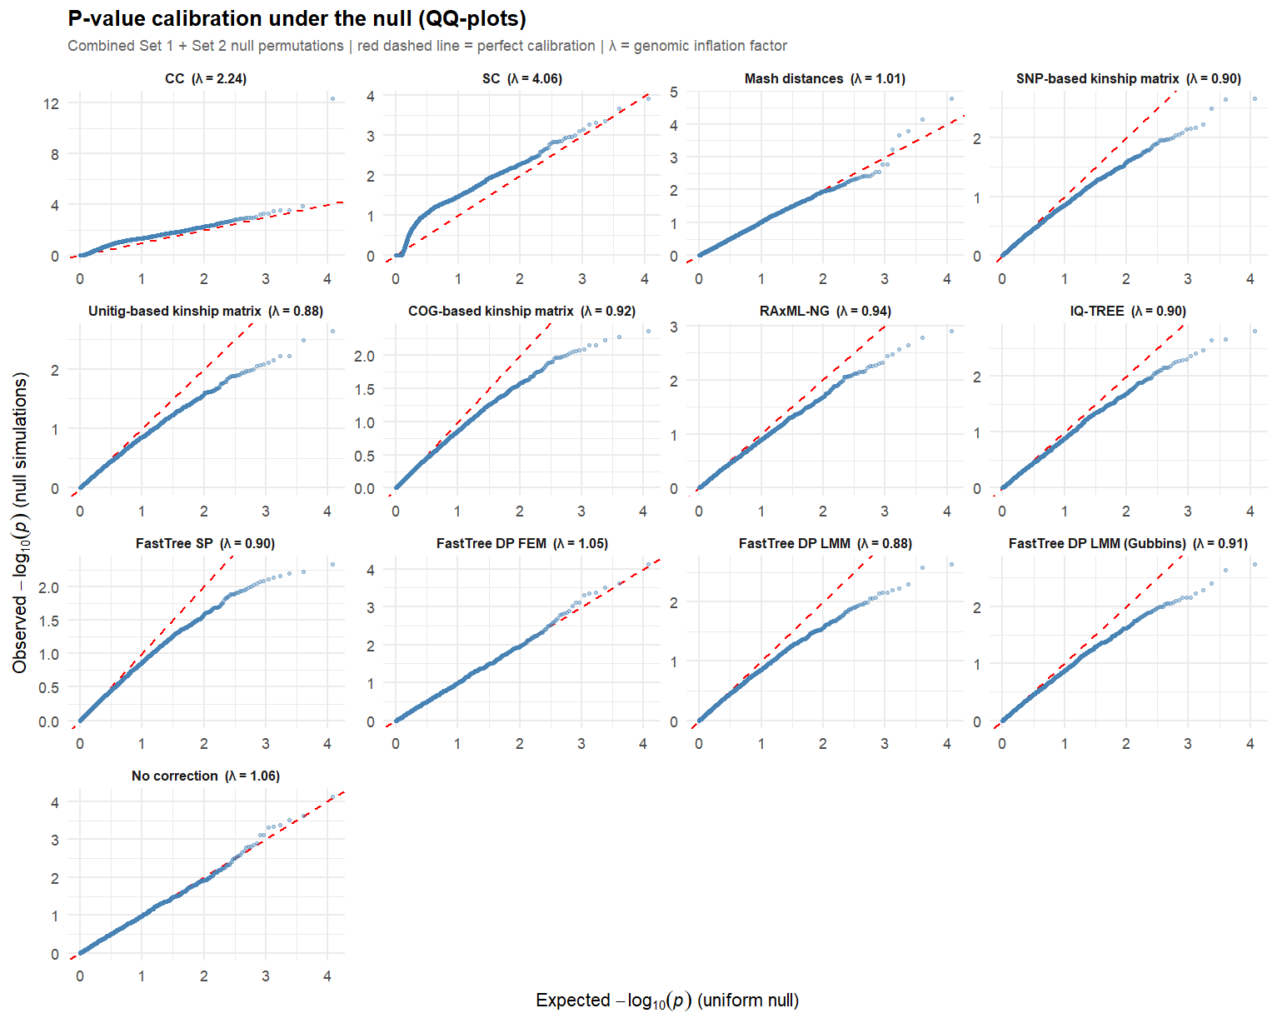
Figure S10. P-value calibration under the null (QQ-plots), by correction method. For each correction method, observed −log₁₀(p) from null (permuted) simulations, pooling Set 1 and Set 2, is plotted against the expected −log₁₀(p) under a uniform null distribution. The red dashed line indicates perfect calibration (observed = expected). λ = genomic inflation factor, the ratio of the median observed to median expected chi-squared test statistic (λ ≈ 1: good calibration; λ > 1: anti-conservative/inflated false-positive rate; λ < 1: conservative). Eleven of 13 methods show λ between 0.88 and 1.06, consistent with appropriate calibration. CC (λ = 2.24) and SC (λ = 4.06) show clear upward deviation from the diagonal in the upper tail, indicating anti-conservative behavior not detected by the threshold-based false-positive rate analysis alone (Figure S9B–C).

